**Final Project Documentation**

**Blank CRUD Checklist**

|  |  |  |  |
| --- | --- | --- | --- |
|  | **Final Project Submission**  **Web Application Development**    **CRUD Check List**    **Date:**  **Team:**  **Grading Team:** | | |
|  | **CRUD use cases** | **Pass** | **Comments** |
| **1** | **View Product** |  |  |
| **2** | **Add to Cart** |  |  |
| **3** | **Delete/Remove Cart Item** |  |  |
| **4** | **Update Account** |  |  |
| **5** | **View Reviews** |  |  |
| **6** | **Update Review for Product** |  |  |
| **7** | **Delete Review for Product** |  |  |
| **8** | **Add Review for Product** |  |  |
| **9** | **Add Product** |  |  |
| **10** | **Update Product** |  |  |
| **11** | **Delete Product** |  |  |
| **12** | **View Sales** |  |  |
| **13** | **View Users** |  |  |
| **14** | **Update Users** |  |  |
| **15** | **Delete Users** |  |  |
| **16** | **Logout Fucntional** |  |  |

**Peer CRUD Checklist**

|  |  |  |  |
| --- | --- | --- | --- |
|  | Final Project Submission  Web Application Development    CRUD Check List    Date: 11/30/2024  Team: Group 9  Grading Team: Group 7 | | |
|  | CRUD use cases | Pass | Comments |
| 1 | View Product | Yes |  |
| 2 | Add to Cart | Yes |  |
| 3 | Delete/Remove Cart Item | Yes |  |
| 4 | Update Account | Yes |  |
| 5 | View Reviews | Yes |  |
| 6 | Update Review for Product | Yes |  |
| 7 | Delete Review for Product | Yes |  |
| 8 | Add Review for Product |  |  |
| 9 | Add Product | Yes | Can insert Picture. Nice touch |
| 10 | Update Product | Yes |  |
| 11 | Delete Product | Yes |  |
| 12 | View Sales | Yes |  |
| 13 | View Users | Yes |  |
| 14 | Update Users | Yes |  |
| 15 | Delete Users | Yes |  |
| 16 | Logout Fucntional | Yes |  |

Use cases guide:

User can create account, update account, delete account, and view account

User can create/add to shopping cart, update shopping cart (add or remove), delete shopping cart (remove items), and view shopping cart

User can create product review, update product review, view product review, and delete product review

User can create website review, update website review, view website review, and delete website review

Admin can create a user account, update users accounts (when updating user account, you have to enter users username before you can submit it), view users accounts, and delete users accounts

Admin can create new product, update product, delete product, view product

Admin can see sales report

**Business/Organizational Goals**

We achieved our business and organizational goals by creating an easy to read website while implementing the necessary components of an e-commerce website to make the customer experience a simple and straightforward process. Our original project objective was to create a user-friendly online shopping experience for our customers. We achieved this goal by creating a clear navigation system at the top of our website when the user logs in so the user knows exactly how to get to a page on our website when needed. This makes the website flow from the user side straightforward for an enjoyable shopping experience. When navigating to the products list, the products are clearly displayed with a picture of the item along with its price and inventory count, leaving no question to our customers about the product that they are purchasing.

**Ethics/Critical Thinking**

When thinking about ethical concerns for our customers, the highest priority was making sure that our customer data is secure. We implemented password hashing and salting for passwords stored in our database, ensuring that if our data is compromised the customers accounts can not be accessed. We also implemented an authentication/authorization process in our login structure so that the website can only be accessed by customers with existing accounts that go through the proper login steps to access the site. Another concern we took into consideration was making sure that our customers can not be misled on our website. Thinking about how we could make the purchasing process as straightforward as possible, on the product list page we decided to include the picture of the item, its name, its price, and its availability according to its inventory count for each item. This ensures that the customers know exactly what they are purchasing, and that it is obvious to the customer if we are out of stock for a specific product. Lastly, we wanted to make sure that all possible customers can have an enjoyable experience on our website. We decided that it would be best if our website was not cluttered with unnecessary features that would not directly contribute to the user experience, and we also decided that large clear lettering and color contrasting that is easy to look at was implemented for people that have visual disabilities.

**USE CASE MODEL**

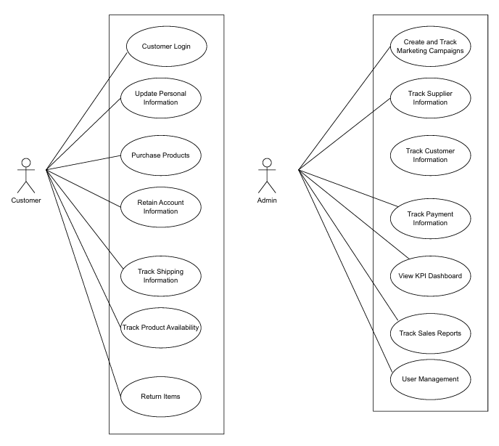

**USE CASE DOCUMENT**

**Actor Use Cases:**

|  |  |  |
| --- | --- | --- |
| **Use Case** | **Customer Login** | |
| Objective | Allow the customer to log in to the system securely. | |
| Business Event | Customer provides login credentials to access their account. | |
| Primary Actor (s) | Customer | |
| Secondary Actor (s) | None | |
| Pre-condition | Customer must have an existing account with valid login credentials. | |
| Post-condition | Customer is logged in and redirected to the home page. | |
| Failure outcomes | Customer is shown an error message if login fails due to incorrect credentials or other issues. | |
| Flow of Events | Actor | System |
| 1 | Customer navigates to the login page. | System displays the login form. |
| 2 | Customer enters username and password. | System validates credentials. |
| 3 | Customer clicks "Login". | If valid, the system logs in the customer and redirects to the home page. |
| 4 |  | If invalid, the system displays an error message: "Incorrect username or password." |

|  |  |  |
| --- | --- | --- |
| **Use Case** | **Purchase Products** | |
| Objective | Allow customers to purchase products from the platform | |
| Business Event | Customer initiates a purchase of products | |
| Primary Actor (s) | Customer | |
| Secondary Actor (s) | Payment Gateway | |
| Pre-condition | Customer must be logged into the system.  Customer must have items in the cart. | |
| Post-condition | Order is confirmed, and payment is processed. | |
| Failure outcomes | Customer receives an error message if the purchase fails. | |
| Flow of Events | Actor | System |
| 1 | Customer navigates to their cart. | System displays cart contents. |
| 2 | Customer confirms items and initiates checkout. | System shows checkout page |
| 3 | Customer provides payment and shipping details. | System processes payment and stores order details.  Forward user to the view-customer-list.php page. |
| 4 | Customer sees order confirmation. | Customer sees order confirmation. |

|  |  |  |
| --- | --- | --- |
| **Use Case** | **Retain Account Information** | |
| Objective | Retain customer account information for future visits. | |
| Business Event | Customer updates or saves personal account details. | |
| Primary Actor (s) | Customer | |
| Secondary Actor (s) | None | |
| Pre-condition | Customer must be logged into the system. | |
| Post-condition | Account details are saved. | |
| Failure outcomes | Customer receives an error message if the details cannot be saved. | |
| Flow of Events | Actor | System |
| 1 | Customer navigates to account settings. | System displays account settings page. |
| 2 | Customer updates account information. | System validates and saves the new information. |
| 3 | Customer submits the changes. | System shows a confirmation message. |

|  |  |  |
| --- | --- | --- |
| **Use Case** | **Track Shipping Information** | |
| Objective | Allow customers to track the status of their shipped orders. | |
| Business Event | Customer checks the shipping status. | |
| Primary Actor (s) | Customer | |
| Secondary Actor (s) | Shipping Provider | |
| Pre-condition | Customer must have an order placed. | |
| Post-condition | Shipping status is displayed. | |
| Failure outcomes | Error message if tracking information is unavailable. | |
| Flow of Events | Actor | System |
| 1 | Customer navigates to order history. | System displays list of customer orders. |
| 2 | Customer selects an order to track. | 2. System retrieves and displays shipping status. |

|  |  |  |
| --- | --- | --- |
| **Use Case** | **Track Product Availability** | |
| Objective | Display product availability to the customer. | |
| Business Event | Customer checks if a product is in stock. | |
| Primary Actor (s) | Customer | |
| Secondary Actor (s) | Inventory System | |
| Pre-condition | Customer is viewing a product page. | |
| Post-condition | Stock status is displayed. | |
| Failure outcomes | System shows an error if availability cannot be determined. | |
| Flow of Events | Actor | System |
| 1 | Customer views a product. | System checks inventory status. |
| 2 |  | System displays availability. |

|  |  |  |
| --- | --- | --- |
| **Use Case** | **Submit a review** | |
| Objective | Allows users to submit a review on either the website or a singular product. | |
| Business Event | Customer initiates a review for the website or a purchased item. | |
| Primary Actor (s) | Customer | |
| Secondary Actor (s) | Database | |
| Pre-condition | Customer must be logged into the website.. | |
| Post-condition | Review is properly written and submitted. | |
| Failure outcomes | Error message if review is empty. | |
| Flow of Events | Actor | System |
| 1 | Customer goes to view reviews page. | System displays reviews. |
| 2 | Customer completes and submits review form. | System processes review and updates database. |
| 3 |  | System confirms the review, adds it to the website. |

|  |  |  |
| --- | --- | --- |
| **Use Case** | **Update Personal Information** | |
| Objective | Allow customers to update their personal information. | |
| Business Event | Customer updates account details. | |
| Primary Actor (s) | Customer | |
| Secondary Actor (s) | None | |
| Pre-condition | Customer must be logged in | |
| Post-condition | Account information is updated. | |
| Failure outcomes | Error message if update fails. | |
| Flow of Events | Actor | System |
| 1 | Customer navigates to account settings. | System displays account settings page. |
| 2 | Customer updates personal information. | 2. System validates and saves information. |
| 3 |  | System confirms the update. |

**Admin Use Cases:**

|  |  |  |
| --- | --- | --- |
| **Use Case** | **User Management** | |
| Objective | Admin can manage user information and role status. | |
| Business Event | Admin manages user information. | |
| Primary Actor (s) | Admin | |
| Secondary Actor (s) | None | |
| Pre-condition | Admin is logged in. | |
| Post-condition | User info is updated or deleted. | |
| Failure outcomes | None | |
| Flow of Events | Actor | System |
| 1 | Admin accesses user management page. | System displays users |
| 2 | Admin makes changes to user information | System saves updated user information |
| 3 |  | System confirms user updating. |

|  |  |  |
| --- | --- | --- |
| **Use Case** | **Track Customer Information** | |
| Objective | Admin can access customer personal information for support. | |
| Business Event | Admin retrieves customer data. | |
| Primary Actor (s) | Admin | |
| Secondary Actor (s) | None | |
| Pre-condition | Admin is logged in. | |
| Post-condition | Customer information is displayed. | |
| Failure outcomes | Error if data retrieval fails. | |
| Flow of Events | Actor | System |
| 1 | Admin searches for customer. | System displays customer details. |

|  |  |  |
| --- | --- | --- |
| **Use Case** | **Track Payment Information** | |
| Objective | Allow admins to view customer payment data. | |
| Business Event | Admin checks customer payment history. | |
| Primary Actor (s) | Admin | |
| Secondary Actor (s) | None | |
| Pre-condition | Admin is logged in. | |
| Post-condition | Payment details are displayed. | |
| Failure outcomes | Error message if retrieval fails. | |
| Flow of Events | Actor | System |
| 1 | Admin selects customer payment history. | System displays payment information. |

|  |  |  |
| --- | --- | --- |
| **Use Case** | **Track Sales Reports** | |
| Objective | Generate sales reports for monthly performance. | |
| Business Event | Admin retrieves monthly sales data. | |
| Primary Actor (s) | Admin | |
| Secondary Actor (s) | None | |
| Pre-condition | Admin is logged in. | |
| Post-condition | Monthly report is generated. | |
| Failure outcomes | Error if report fails. | |
| Flow of Events | Actor | System |
| 1 | Admin selects sales report option. | System generates and displays report. |

**ACTIVITY DIAGRAMS: USER CASES**

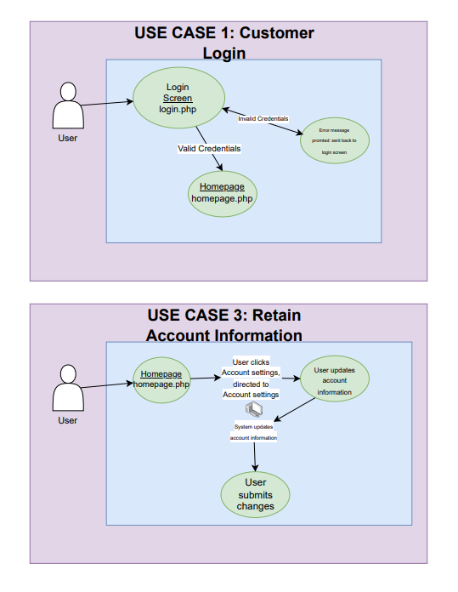

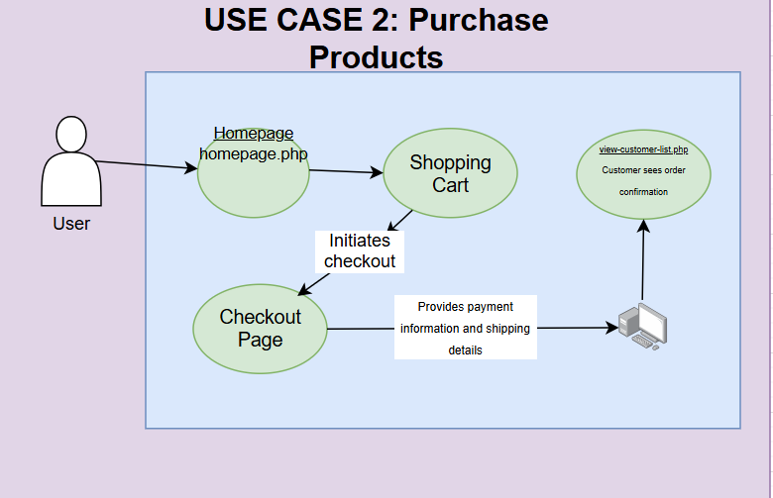

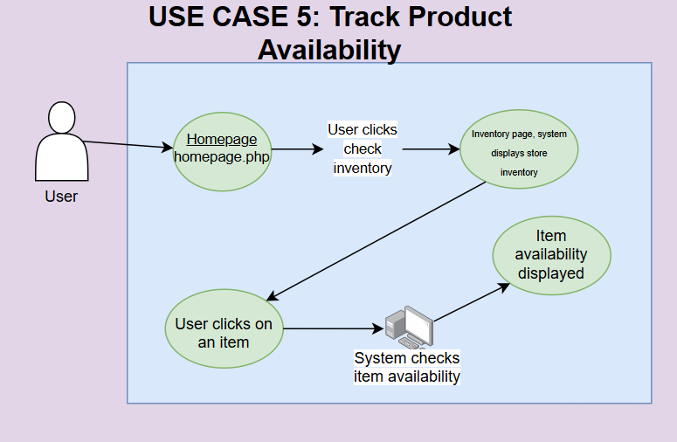

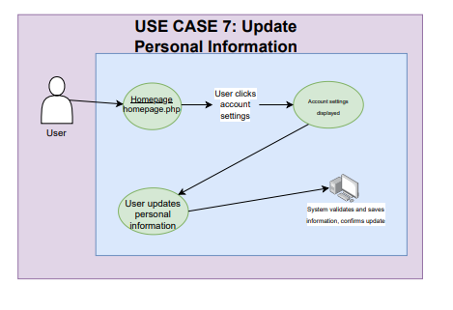

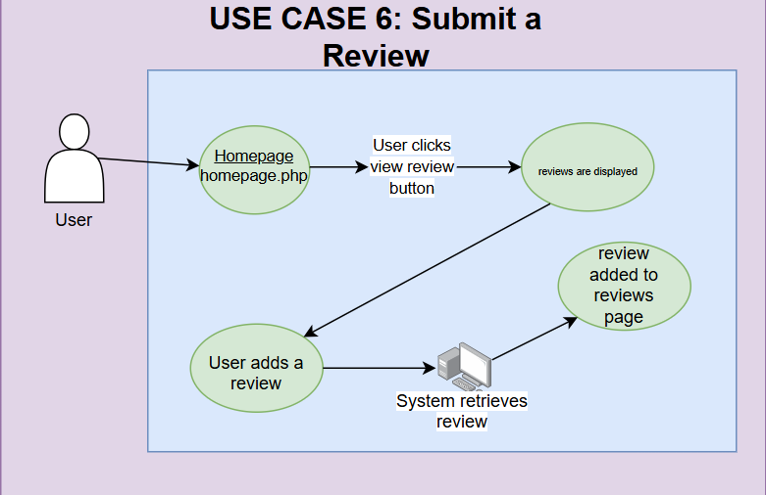

**ACTIVITY DIAGRAM: ADMIN CASES**

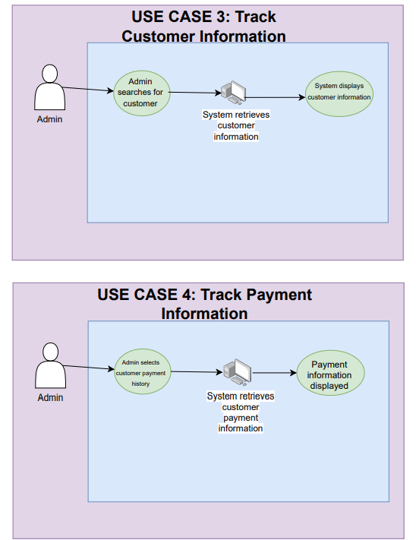

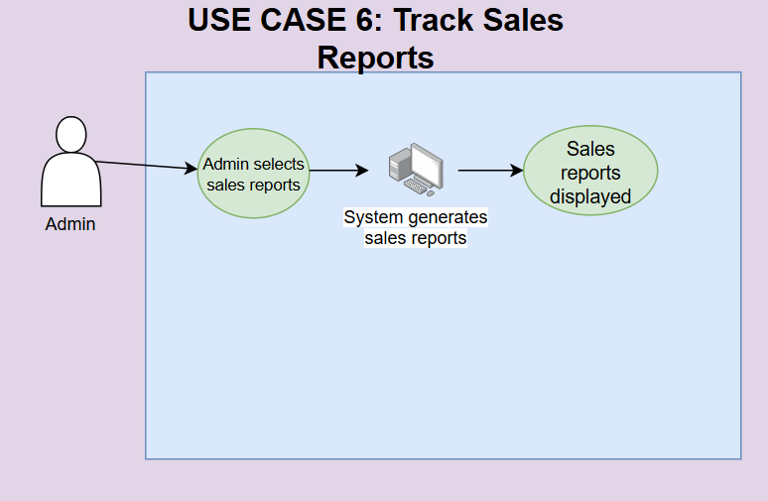

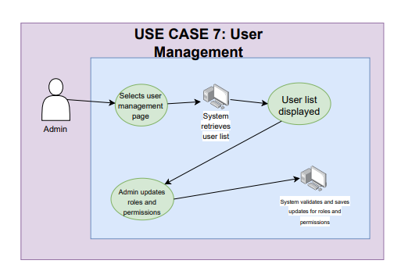

**WIREFRAMES: USER CASES**

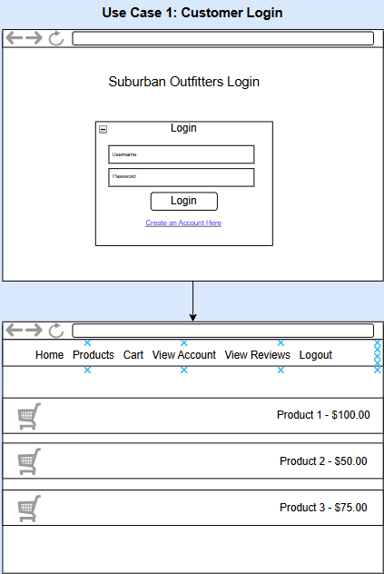

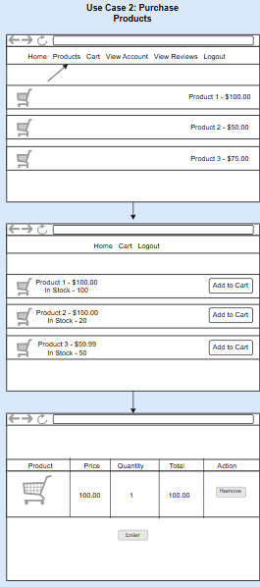

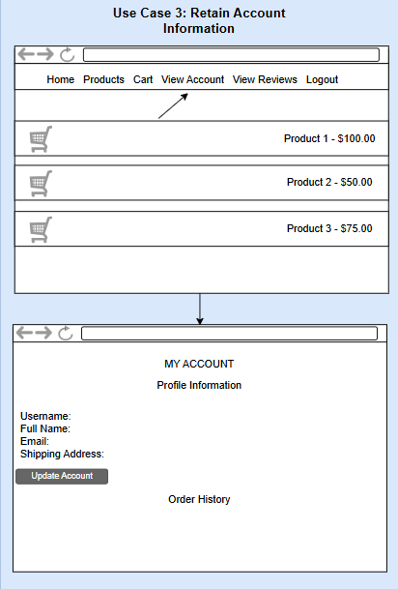

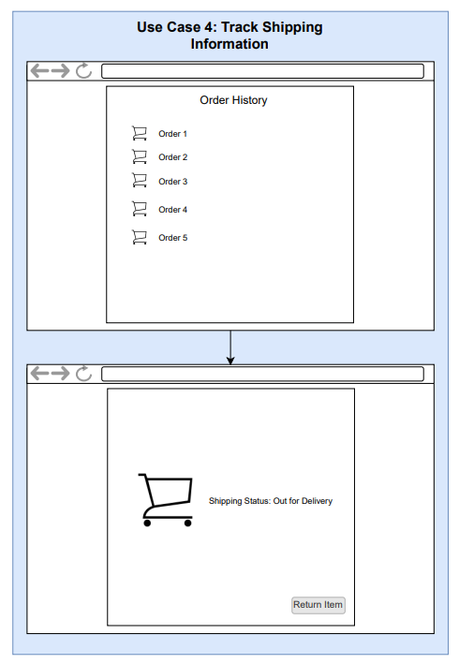

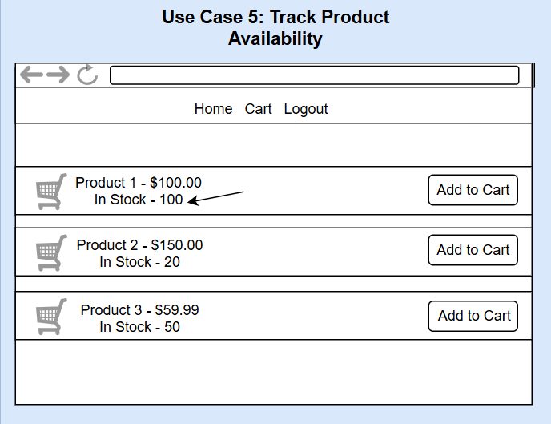

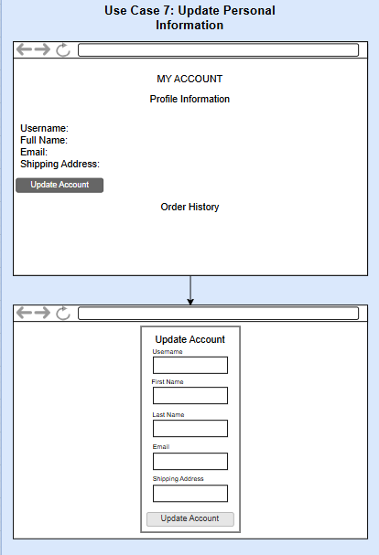

**WIREFRAMES: ADMIN CASES**

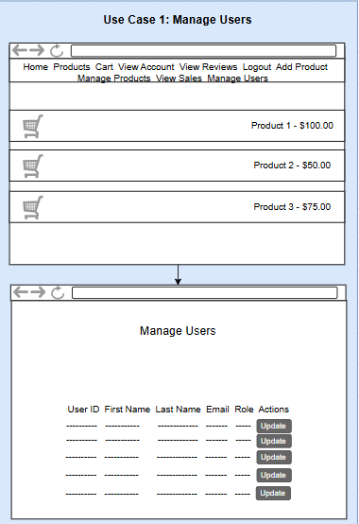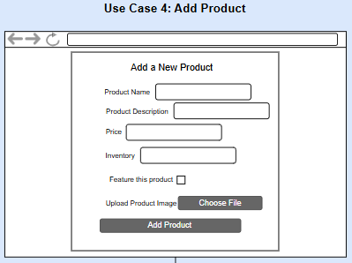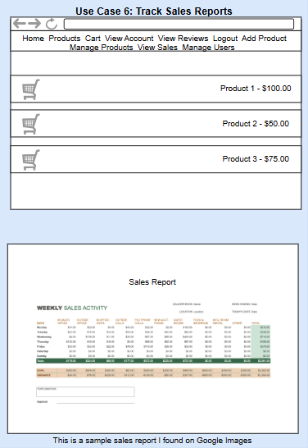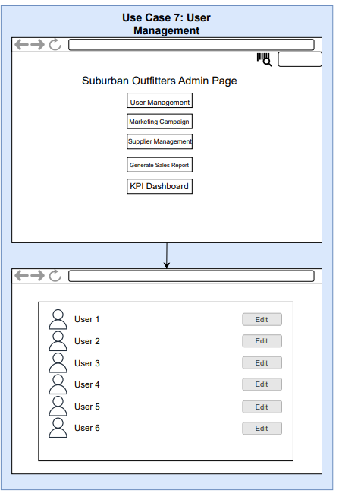

**ERD DIAGRAM**

